PICSART:

Outline for the Presentation and Defense of the Project

1. Introduction (2-3 minutes)
- Personal introduction: Name and a brief description of your role as a user of the app (e.g., "I am regular user of this app for...").
App introduction:
- Name of the application: picsart
- Type of application (category or sector: health, productivity, finance, etc.).: Photography
- Main purpose of the app: Full suite of AI powered editing features, quickly remove and swap backgrounds for the perfect product shots, design flyers or social media posts with templates, create photo collages of your favorite memories, choose from hundreds of stylized photo filters.

2. General information about the app (5 minutes)
Developers:
- Name of the company or developers: PicsArt, Inc.
- Brief history or interesting facts about its creation.
https://es.wikipedia.org/wiki/PicsArt
- Founded in 2011
offering a platform that provides creators with the power to advance their passions through intuitive tools and exclusive content. With easy-to-use editing tools powered by AI, one of the world’s largest open-source content collections, customizable templates, and a simple user interface, On our platform, creators make everything from brand logos and podcast covers to e-commerce shop visuals, trending social media content, and merch. Using the world’s largest digital creation platform with 150M+ active monthly users, a top 20 most downloaded app worldwide for 2021, and in over 30 languages, you can design the now, too.
Availability:
- Platforms where it is available (Android, iOS, web, etc.)
- Business model: free, freemium, subscription, etc: freemium*
*Picsart operates on a “freemium” model, offering a range of features and tools at no charge. Purchasing a premium, Gold membership unlocks all of Picsart’s advanced photo and video editing tools, delivering endless opportunities for creative expression. https://picsart.com/about-us/?_gl=1*1nk1l02*_up*MQ..*_ga*ODE4OTk4NjUzLjE3MzY4ODY2ODQ.*_ga_FQMFEN0QZ1*MTczNjg4NjY4NC4xLjAuMTczNjg4NjY4NC4wLjAuMA..
- PicsArt contiene diversas herramientas para editar imágenes y dibujar. Cuenta con 120 filtros para fotografías, de los cuales 40 solo están disponibles con «PicsArt Gold» (suscripción de pago mensual).

Target audience:
- Who is the app designed for?
Marketers, small business owners, solopreneurs, social media managers, content creators. or influencers.
- What problem does it solve or what need does it address?
easy-to-use photo and video editing tools, filters, and content allow creators of all skill sets to design professional-quality work, fast.

3. Key functionalities (6-7 minutes)
Description of key features:
- Select at least three main features.
- Explain them clearly and simply.
- What value do they provide to the user?
https://play.google.com/store/apps/details?id=com.picsart.studio&pli=1
- 1. AI EDITOR:
  - Removes a background of an image automatically without a trace
  - Enhances blurry and pixelated photos, no need for pro editing skills
  - Turns text into imaginative visuals: You type a detailed description into the AI image generator to create images or custom illustrations, From photorealistic images to classic art and even custom stickers
  - Use AI replace to transform parts of your image with ease or take advantage of AI sketch to turn even the most haphazard sketches into art.
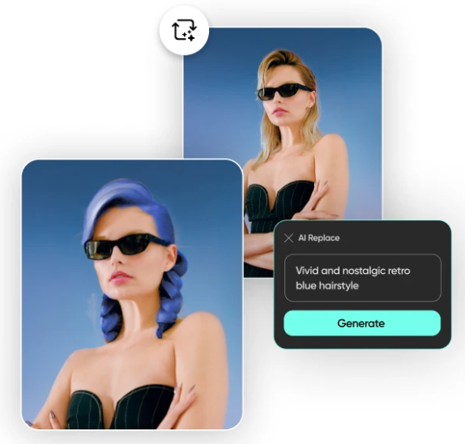

  - Has a suite of ai tools

- 2. EDITOR DE FOTOS
• Prueba filtros que son tendencia y efectos populares para fotos
• Utiliza el Borrador de Fondos para eliminar y reemplazar fondos
• Mejora tus fotos y elimina objetos no deseados con la herramienta Remover Objeto
• Utiliza millones de fotos gratis seleccionadas o edita tus propias fotos
• Añade texto en tus fotos con más de 200 fuentes de diseño
• Retoca selfies, agrega filtros, cambia el color del cabello, coloca stickers de maquillaje y mucho más
• Desenfoca el fondo con nuestra herramienta de selección inteligente con IA
• Recorta y voltea fotos rápidamente
• Añade stickers a tus fotos y crea tus propios stickers
- 2. EDITOR DE VIDEOS
• Crear y editar videos con nuestro editor de videos con música es muy fácil
• Lleva tus historias de IG, TikToks y Reels al siguiente nivel
• Añade música a tus videos utilizando nuestra gran biblioteca de música en el editor de videos
• Prueba los efectos de video Glitch y otros filtros que son tendencia en el editor de videos
• Recorta videos o usa la función inteligente para unir y fusionar videos
• Añade tus mejores momentos en un collage de videos
3. For Business > Brand identity generator:
https://picsart.com/brand-identity-generator/?_gl=1*1lbe9nb*_up*MQ..*_ga*MTUwOTYxMzguMTczNzczNDkwOA..*_ga_FQMFEN0QZ1*MTczNzczNDkwNy4xLjAuMTczNzczNDkwNy4wLjAuMA..

API/SDK and other tools:
https://docs.picsart.io/docs/creative-apis-getting-started

Highlights:
- User Interface (UI): Is it easy to use? Why?
- User Experience (UX): How intuitive is navigation? What makes it efficient

5. Critical analysis (3-4 minutes)
Advantages:
- What makes this app stand out compared to others?
- What are its strengths?
Limitations:
- What aspects could be improved?
- Opinion on potential future features or necessary improvements.
Comparison:
- Are there similar apps? If yes, how does this one differ?

6. Conclusion (1-2 minutes)
App summary:
- A brief statement about the value it provides.
Recommendation:
- Would you recommend this app to other users? Why? What type of user would benefit the most?

